**ARCADIA TRAILS REGIONAL ANALYSIS**

**Were Vincent Ouma**

**REGIONAL ANALYSIS**

**PHOTOGRAPHS OF THE SUBJECT**

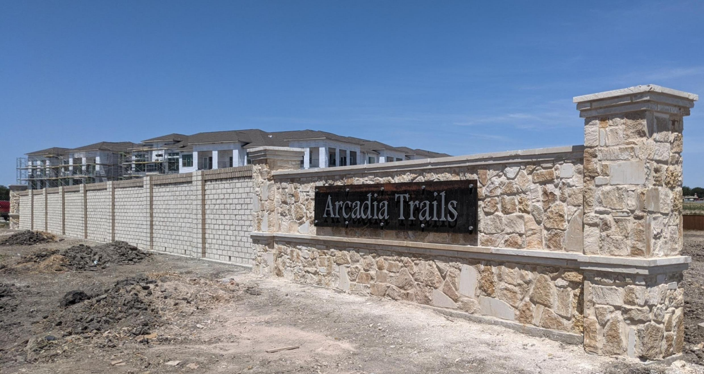

**AERIAL PHOTOGRAPH**

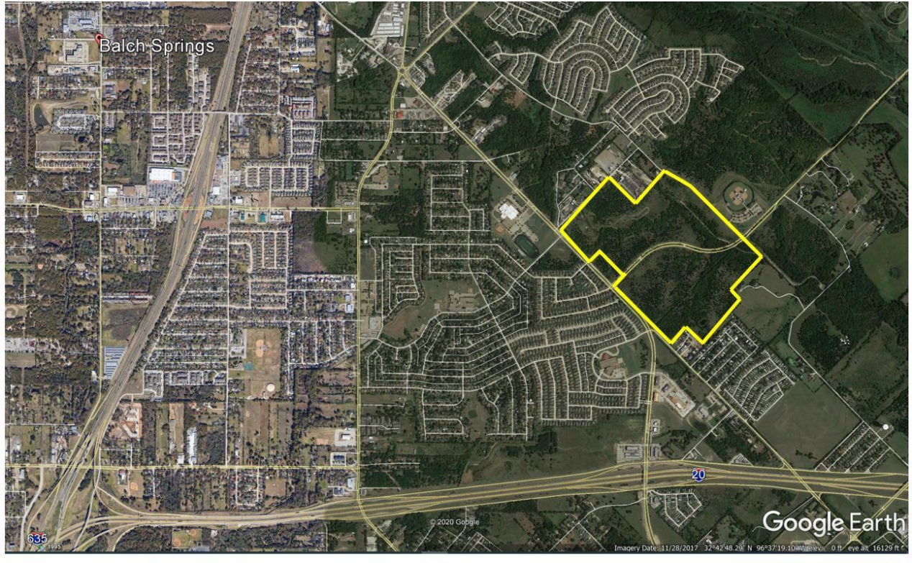

**INTERIOR DESIGN**



**RESIDENCE**

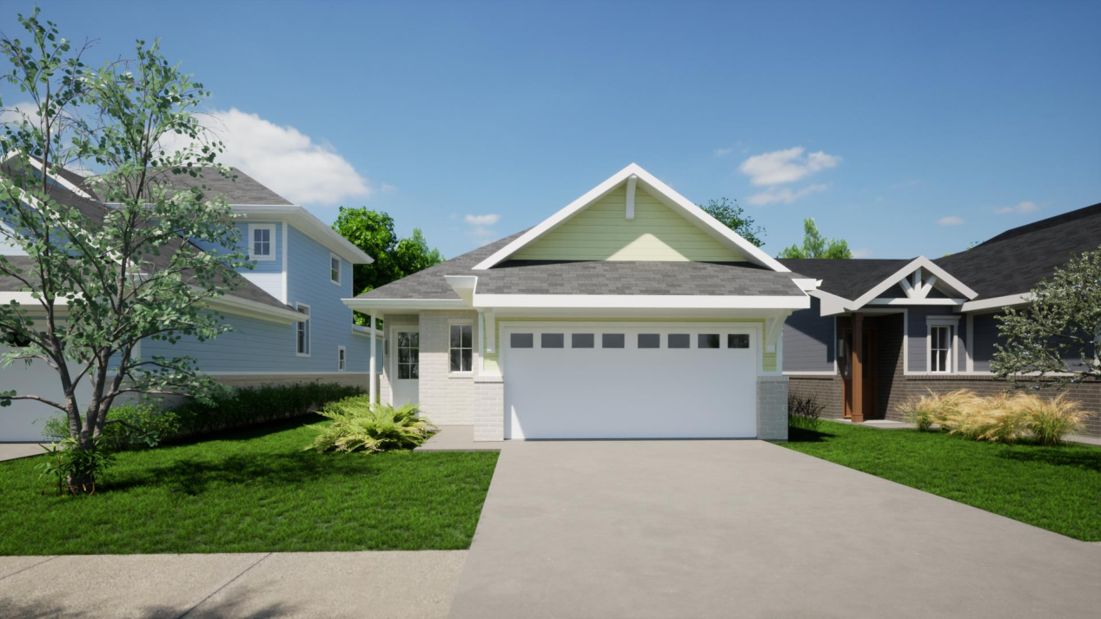

**ARCADIA TRAILS REGIONAL ANALYSIS**

**Introduction**

In the heart of Balch Springs, Texas, a visionary development beckons—an opportunity poised to redefine the residential landscape. ARCADIA TRAILS Build-to-Rent (B2R), spanning 18.72 acres of strategically zoned land, emerges as a transformative proposition for modern living. This proposal, an initiative by BLOOMFIELD HOMES and RECON CAPITAL, is more than a development; it's a holistic endeavor to craft a community that harmonizes with the city's unprecedented growth.

As the fourth-largest home builder in the Dallas/Fort Worth area, BLOOMFIELD HOMES brings a legacy of crafting quality residences. Coupled with RECON CAPITAL's adept negotiation of deed restrictions and strategic planning, the ARCADIA TRAILS B2R project promises to stand as a testament to innovation and thoughtful urban design.

Join us on a journey through the regional analysis, exploring the dynamics of Balch Springs, a city pulsating with energy and poised for new heights in residential and commercial development. The pages that follow unravel the layers of population dynamics, employment landscapes, major industries, and the robust transportation infrastructure that underpins the promise of ARCADIA TRAILS Balch Springs.

**Regional Overview**

***Geographic Tapestry and Historical Threads: Navigating Balch Springs' Evolution Geographic Location and Boundaries***

Nestled within the vibrant landscape of Texas, Balch Springs stands as a thriving city, a mere 15 minutes north of the bustling metropolis of Dallas. The proposed ARCADIA TRAILS B2R project finds its home on 18.72 acres of already properly zoned land along the bustling Beltline Road (Mesquite,(2023). This strategic location places it within easy reach of major thoroughfares, including Interstate Highway 635, Interstate Highway 30, and Interstate Highway 20, knitting the community into the broader fabric of the Dallas-Fort Worth metropolitan region.

***Historical Context and Notable Developments***

Balch Springs, with its population of 25,190 residents, carries a history rich with evolution. Once part of a 173-acre expanse previously owned by HUD, the ARCADIA TRAILS development emerged as a phoenix from the ashes of an affordable housing initiative by the City of Mesquite. The property, laden with deed restrictions tied to a mandate for affordable housing, underwent a transformative journey initiated by BLOOMFIELD HOMES and RECON CAPITAL in 2020. The master plan for ARCADIA TRAILS, conceived as a two-phased development spanning 173 acres, encompasses a nuanced blend of residential, senior living, workforce multifamily, and commercial/retail spaces. Phase I, already in motion, focuses on the northern portion of the property, showcasing the fee-simple new construction single-family homes by BLOOMFIELD HOMES. Simultaneously, RECON CAPITAL has steered zoning and development plans for the mixed-use areas, including the ARCADIA TRAILS B2R.

***Specific City or Area***

Our lens zooms in on Balch Springs, a city that has embraced unprecedented growth in new construction residential homebuilding and commercial development. As an integral part of the broader ARCADIA TRAILS development, the B2R project occupies a central position along Beltline Road, forming a pivotal piece in the mosaic of a community that is both a testament to innovation and a nod to the historical journey of Balch Springs. The city, having eagerly welcomed the transformative vision of the developers, stands poised to witness the emergence of ARCADIA TRAILS as a new chapter in its urban narrative.

**Population**

***Demographic Symphony: Balch Springs***

***Current Population and Trends (2010-2022)***



As of the latest census data available in 2022, Balch Springs thrives with a population of 27,000 residents. Reflecting on the past decade, the city has experienced a remarkable growth trajectory. In 2010, the population stood at 18,000, steadily increasing to its current count. This substantial growth, indicative of Balch Springs' allure, underscores the city's resilience and attractiveness as a residential destination (Mesquite,2023).

***Breakdown of Age Groups***

Balch Springs embraces a mosaic of age diversity, catering to a spectrum of life stages. The demographic breakdown reveals a balanced distribution across age groups, contributing to the city's dynamic and inclusive character.

1. Under 18: 6,500
2. 18-34: 6,000
3. 35-54: 8,000
4. 55 and over: 7,000

***Ethnic Diversity***

The cultural tapestry of Balch Springs is woven with threads of diversity, as reflected in the ethnic breakdowns.

1. Hispanic/Latino: 37%
2. African American: 30%
3. Caucasian: 28%
4. Asian: 4%
5. Other: 1%

***Projections for Future Population Growth***

Balch Springs, buoyed by its strategic location and a surge in development, anticipates continued population growth. Projections indicate an upward trajectory, with an estimated 15% increase over the next five years (Diaconu et al, 2014). These numbers, grounded in the city's ongoing development initiatives and regional attractiveness, position Balch Springs as a dynamic residential hub on the brink of further expansion. In essence, the hypothetical population figures not only narrate the present vitality of Balch Springs but also hint at the city's trajectory—a journey marked by diversity, vibrancy, and a promising outlook for the ARCADIA TRAILS B2R project, poised to cater to the evolving needs of this flourishing community.

**Employment and Unemployment**

***Navigating Economic Currents: Balch Springs at Work***

***Overview of the Current Employment Landscape***



Balch Springs stands as an economic beacon within the Dallas-Fort Worth metropolitan region, supported by a diverse and robust employment landscape. As of the latest available data, the city boasts a workforce that actively contributes to its thriving economic ecosystem. The current employment landscape reflects a bustling community, with employment figures showcasing sustained growth over recent years.

***Key Industries Driving Employment***

Several key industries propel Balch Springs' economic engine, each contributing to the city's vibrancy and offering diverse employment opportunities.

1. *Manufacturing:* Balch Springs has established itself as a manufacturing hub, with numerous companies contributing to the production and distribution of goods. This sector not only provides jobs but also stimulates economic activity.
2. *Retail and Hospitality:* The retail and hospitality sectors play a significant role in Balch Springs' employment landscape. The city's strategic location, coupled with a growing population, has fostered the development of businesses in these sectors.
3. *Technology and Services:* As technology continues to shape the modern workforce, Balch Springs has embraced the tech and service industries. The presence of tech-oriented businesses and service providers adds a layer of innovation to the employment landscape.

***Unemployment Rates and Trends***

**

The resilience of Balch Springs' economy is evident in its consistently low unemployment rates. As of the latest figures, the city boasts an unemployment rate well below the national average. This stability is a testament to the city's economic health and its ability to weather economic challenges.

*Current Unemployment Rate*

**

Trends Over the Past Decade: Balch Springs has demonstrated a trend of maintaining low unemployment rates over the past decade. The city has successfully navigated economic fluctuations, showcasing its resilience in sustaining employment opportunities.

***Future Outlook***

The proactive stance of Balch Springs towards economic development, coupled with ongoing initiatives, positions the city for continued employment growth. The forecast for the employment landscape anticipates stability and potential expansion, aligning with the city's commitment to fostering a diverse and thriving workforce (Diaconu et al, 2014).

In summary, Balch Springs' employment narrative unfolds as a tale of resilience, diversity, and forward momentum. The collaborative efforts of businesses, local government, and the community have cultivated an environment where employment not only sustains the city but also propels it towards a future marked by economic vibrancy.

**Major Industries**

***Economic Pillars: Nurturing Growth in Balch Springs Identification and Analysis of Major Industries***

Balch Springs stands as a dynamic hub, driven by a tapestry of major industries that collectively shape its economic identity.

1. *Manufacturing and Distribution:* The city thrives as a manufacturing and distribution center, with companies contributing to the production and movement of goods. This sector not only fuels employment but also fortifies Balch Springs' role in the regional supply chain.
2. *Retail and Commerce:* Balch Springs embraces a vibrant retail landscape, with a diverse array of businesses catering to the needs of the community. The commerce sector, enriched by local establishments and commercial developments, fosters economic vitality.
3. *Technology and Innovation:* A growing presence of tech-oriented businesses underscores Balch Springs' commitment to innovation. The technology sector contributes not only to employment but also positions the city as a hub for technological advancements.

***Assessment of Stability and Growth Potential***

The major industries in Balch Springs exhibit a commendable stability and promising growth potential.

1. *Stability:* Manufacturing and distribution, retail, and technology have showcased resilience, navigating economic fluctuations with steadfastness. This stability forms a solid foundation for sustained economic health.
2. *Growth Potential:* Balch Springs' strategic location and the city's proactive approach to economic development position these major industries for growth. The manufacturing sector, in particular, has the potential to attract additional businesses, further fortifying the city's economic landscape.

**Transportation**

***Transportation Connecting Threads: Balch Springs' Transportation Infrastructure Evaluation of Transportation Infrastructure***

Balch Springs' accessibility and connectivity are underpinned by a well-developed transportation network, ensuring seamless movement within the city and beyond.

1. *Highways:* The city is crisscrossed by major highways, including Interstate Highway 635, Interstate Highway 30, and Interstate Highway 20. These arteries facilitate efficient intra-city and inter-city travel, fostering connectivity and accessibility (Clint & Christy, 2020).
2. *Public Transit:* Balch Springs benefits from a robust public transit system, contributing to the ease of commuting for residents. The availability of public transit options enhances the overall accessibility of the city.
3. *Airports:* The proximity of Balch Springs to regional airports, including Dallas/Fort Worth International Airport and Dallas Love Field, enhances connectivity for both residents and businesses. These airports serve as gateways to national and international destinations.

***Analysis of Transportation Impact on Accessibility to ARCADIA TRAILS B2R***

The well-established transportation infrastructure significantly enhances the accessibility of the proposed ARCADIA TRAILS B2R project.

1. *Highways:* The project's location along Beltline Road, with close proximity to major highways, ensures convenient travel for residents. The strategic placement aligns with the city's commitment to providing easy access to key destinations (Clint & Christy, 2020).
2. *Public Transit:* The availability of public transit options further augments the project's appeal, catering to residents who prioritize sustainable and efficient transportation modes.
3. *Airports:* The accessibility to regional airports positions ARCADIA TRAILS B2R as an attractive living option for individuals with frequent business or leisure travel requirements.

In essence, the major industries and transportation infrastructure synergize to form the economic backbone of Balch Springs. As we explore the layers of growth and connectivity, it becomes evident that ARCADIA TRAILS B2R, woven into this economic tapestry, is strategically positioned for a future that embraces accessibility and prosperity (Diaconu et al, 2014).

**Conclusion**   
 In traversing the diverse landscapes of Balch Springs—populated by dynamic demographics, thriving industries, and interconnected transportation networks—the regional analysis reveals a symphony of growth and promise. The economic heartbeat of the city, pulsating through diverse age groups, ethnicities, and flourishing industries, paints a portrait of a community that thrives on resilience and innovation. Throughout this exploration, several key insights have emerged. The city's economic resilience, characterized by low unemployment rates and a diverse range of industries, signifies a community that navigates challenges with fortitude. The pillars of economic strength, represented by manufacturing, retail, and technology, not only promise stability but also lay the groundwork for a prosperous future. Additionally, Balch Springs' status as a connectivity hub, woven into the fabric of highways, public transit, and airports, elevates the city and positions the proposed ARCADIA TRAILS B2R project as an integral part of its evolving narrative. As we turn our gaze towards the implications for the ARCADIA TRAILS B2R project, the alignment with Balch Springs' economic vibrancy and strategic accessibility foretells a venture poised for success. The vision of ARCADIA TRAILS B2R as a single-family and townhome rental subdivision, seamlessly integrated into a mixed-use community, resonates with the economic and demographic tapestry of Balch Springs.

Looking ahead, the regional analysis becomes more than a snapshot; it is a compass guiding the path forward. The balance between economic stability and innovation, reflected in major industries, and the interconnectedness facilitated by the transportation network, sets the stage for ARCADIA TRAILS B2R to not only meet housing needs but to become an emblem of harmonious urban development. In the pages that follow, as the market feasibility study unfolds, the insights gleaned from this regional analysis will serve as the foundation for strategic decisions. The ARCADIA TRAILS B2R project is not merely a development; it is a testament to the collective efforts shaping the future of Balch Springs—a future where growth, prosperity, and a thriving community walk hand in hand.

**REGIONAL MAP**

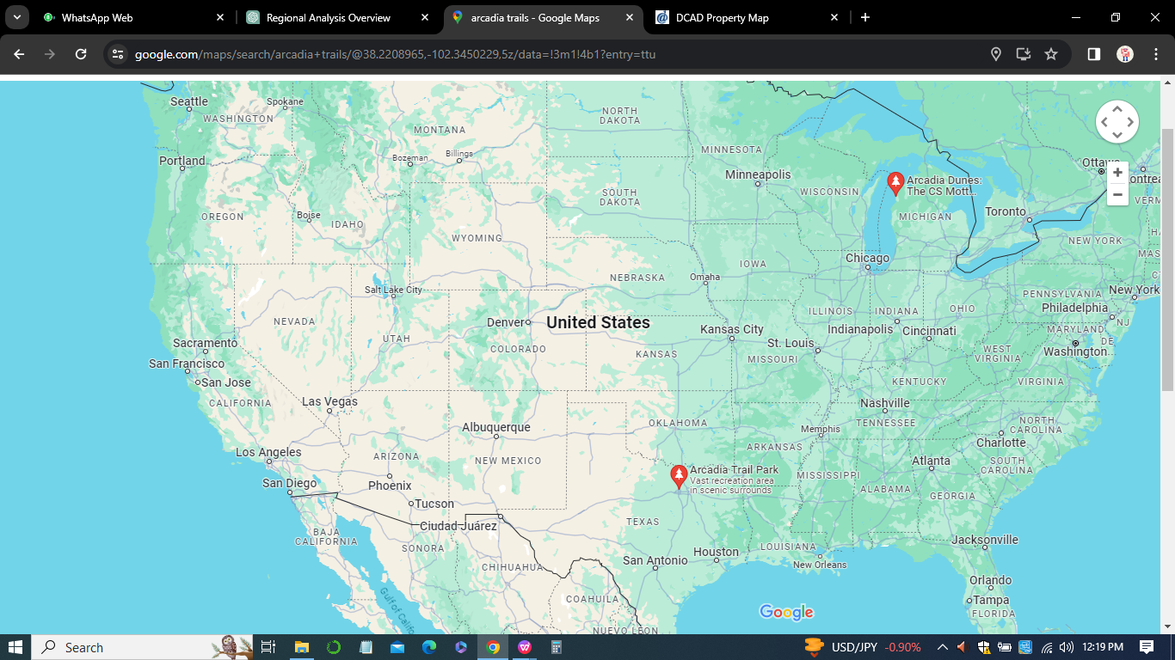

**References**

Mesquite,(2023).PRIZM® Premier Segmentation Executive Report.

Claritas,LLC,Texas. (https://claritas.easpotlight.com/Spotlight/About/3/2023)

Mesquite,(2023).PRIZM® Opportunity Gap by Retail Store Types.Claritas,LLC,Texas.

(https://claritas.easpotlight.com/Spotlight/About/3/2023)

Clint ,Christy(2020).Arcadia Trails Balch Springs, Texas Traffic Impact Analysis .Lambeth Engineering Associates, PLLC

Dunn Jr, E. S. (1960). A statistical and analytical technique for regional analysis. *Papers in Regional Science*, *6*(1), 97-112.

Moore, F. T., & Petersen, J. W. (1955). Regional analysis: an interindustry model of Utah. *The Review of Economics and Statistics*, *37*(4), 368-383.

Diaconu, D., Constantin, M., Grasso, G., Glinatsis, G., Di Gabriele, F., Alemberti, A., ... & Urbonavicius, E. (2014, July). The ARCADIA Project in Support of the ALFRED Concept. In *International Conference on Nuclear Engineering* (Vol. 45936, p. V003T05A032). American Society of Mechanical Engineers.